Report on the Celebration of 150th Anniversary of Vande Mataram at Kokrajhar University.

Title of the Programme: Celebration of 150th Anniversary of Vande Mataram.
Date: 7th November, 2025.
Venue: MMB Hall, Kokrajhar University.

Objective:
The programme was organized to commemorate the 150th Anniversary of Vande Mataram, aiming to recall its historical importance and to inspire the younger generation with the spirit of patriotism, national integration and cultural pride that the song represents.

Dignitaries Present:
The live streaming programme was graced by the presence of:
- Prof. Ganesh Chandra Wary, Hon’ble Vice Chancellor, Kokrajhar University
- Dr. Dimacha Dwibrang Mwchahary, Registrar, Kokrajhar University
- Dr. Bimal Kanti Basumatary, Dean of Students’ Welfare (DSW), Kokrajhar University

Participants:
- Students: Approximately 130 students, including NSS volunteers, actively took part in the event.
- Faculty Members: A total of 9 faculty members from various departments attended and contributed to the programme.

Programme Highlights:
The celebration began with viewing the live telecast of the national and state-level celebrations organized to mark this historic occasion, followed by the Mass Singing of the National Song. Students, faculty members and dignitaries assembled to witness the national and state event where the Hon’ble Prime Minister of India and the Hon’ble Chief Minister of Assam addressed the nation, highlighting the historical and patriotic significance of Vande Mataram composed by Bankim Chandra Chattopadhyay. The live broadcast offered a valuable opportunity for students to connect with the larger national sentiment and to understand the unifying spirit and cultural pride that the song continues to inspire even after 150 years.
The atmosphere during the telecast was marked by patriotic enthusiasm. Students and faculty members attentively followed the proceedings and reflected upon the historical importance of Vande Mataram as a symbol of India’s struggle for freedom and unity. Following the telecast, the participants joined together in the collective singing of Vande Mataram, which created a sense of shared pride and devotion toward the nation. The event concluded with a brief expression of thanks to all present for their participation and cooperation, marking a successful and meaningful commemoration of this landmark occasion.

Outcome:
The celebration served as an inspiring platform for students to understand the importance of Vande Mataram in India’s freedom struggle and its continued significance as a symbol of unity, integrity and national pride.

Conclusion:
The celebration of the 150th Anniversary of Vande Mataram was a memorable and inspiring occasion that brought together students, faculty members and university officials in a shared spirit of patriotism and cultural pride. The programme successfully reminded everyone of the historical significance of Vande Mataram - a song that not only ignited the flames of India’s freedom movement but also continues to resonate as a timeless symbol of unity, devotion and national consciousness. It also provided an educational and emotional experience for the young participants, encouraging them to reflect on the sacrifices made during the struggle for independence and to uphold the values of integrity, brotherhood and love for the motherland in their own lives.

Registrar
Kokrajhar University
Glimpses of the Programme
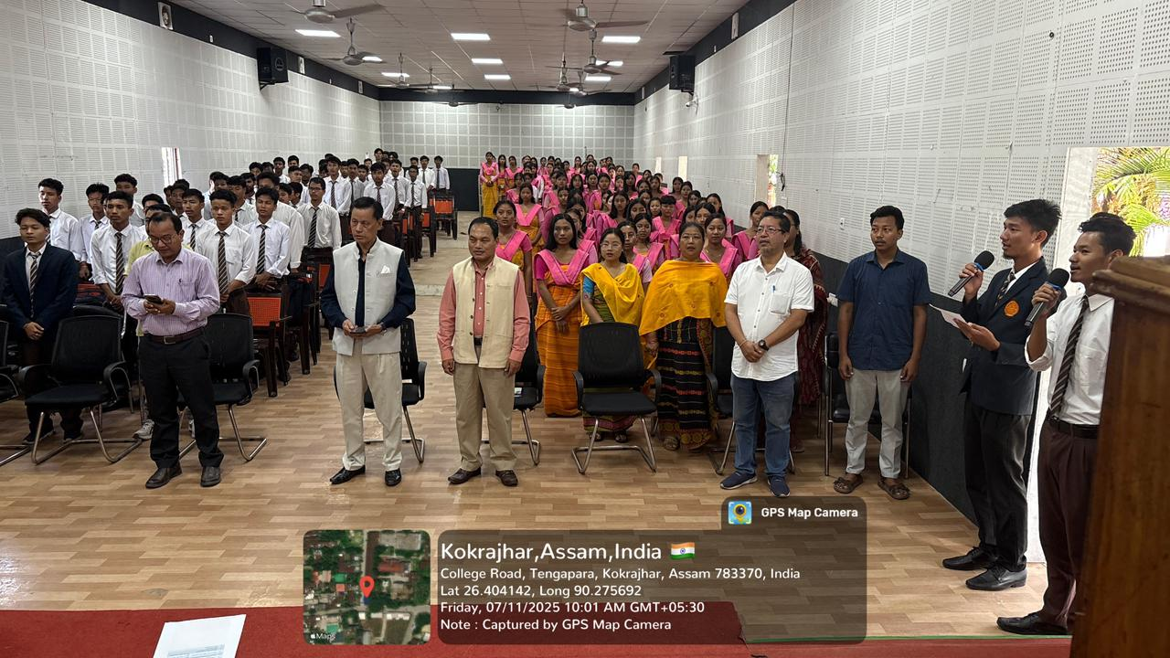
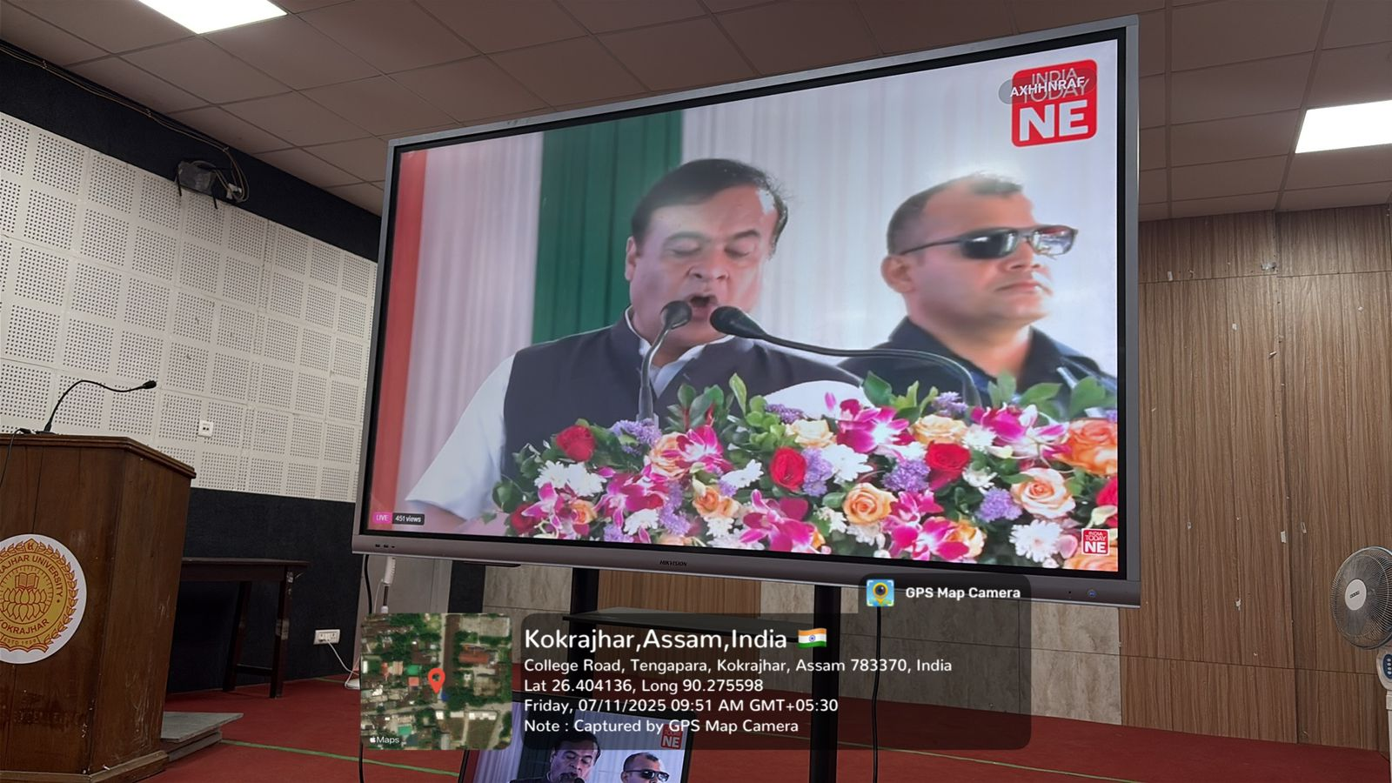
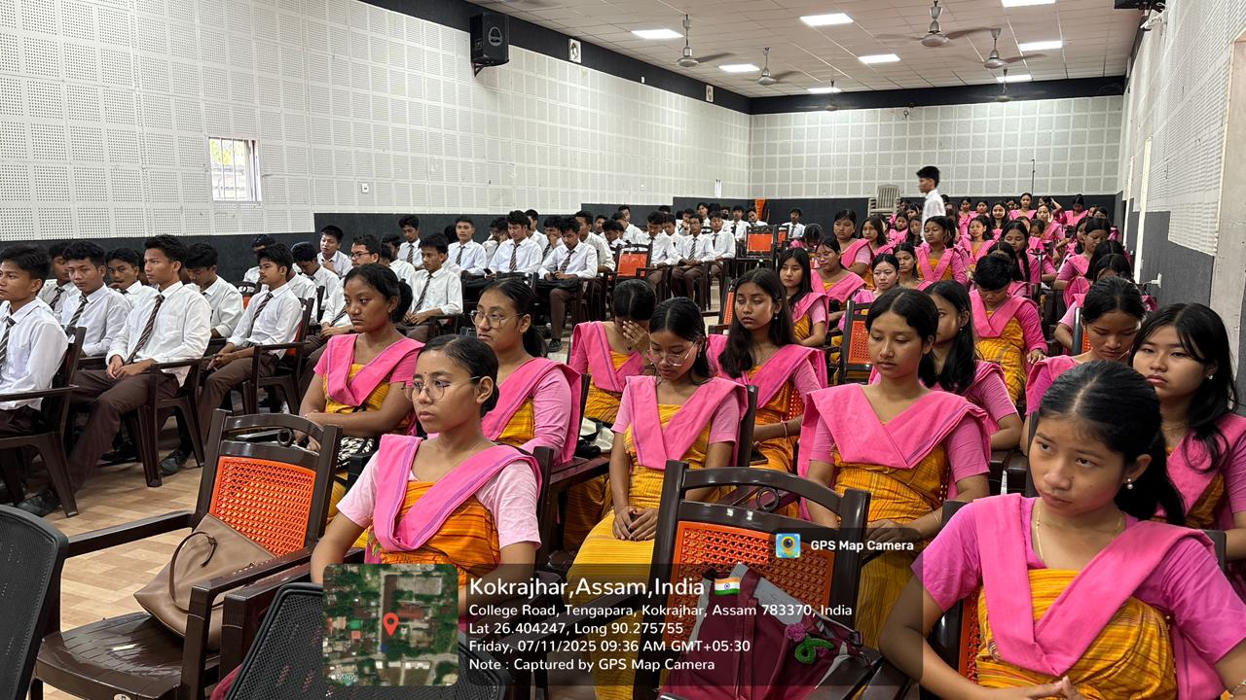
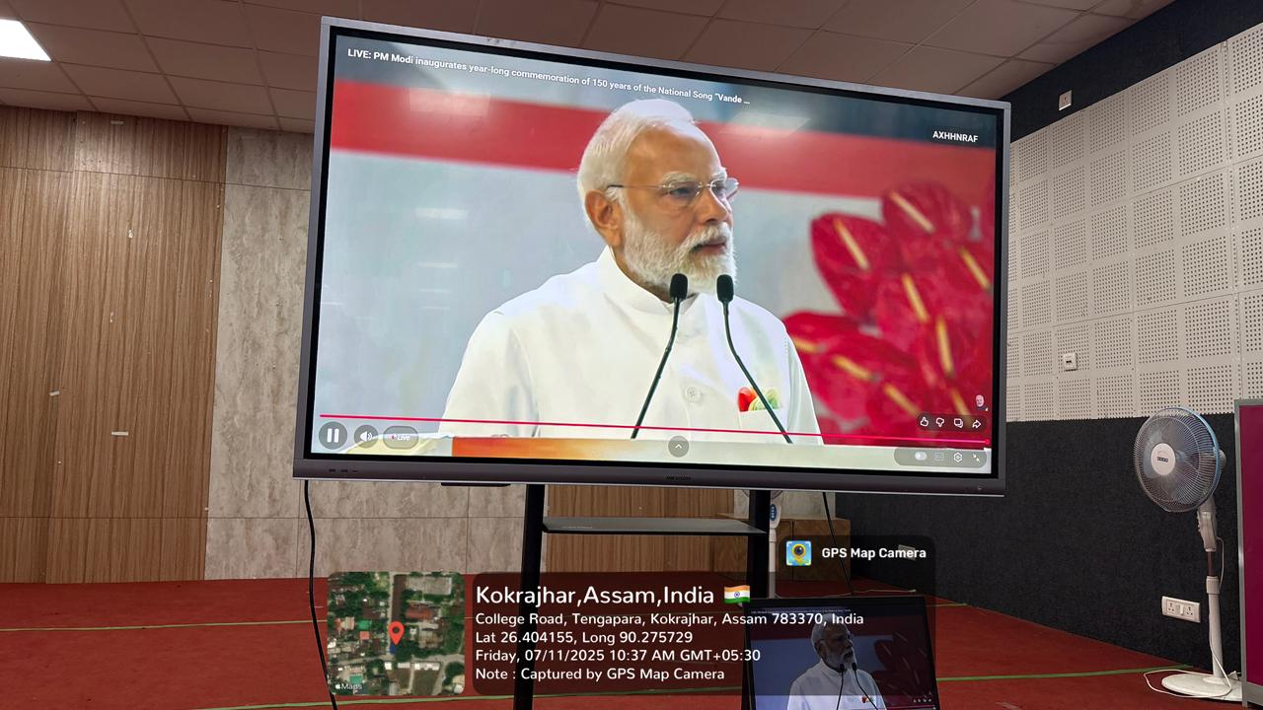

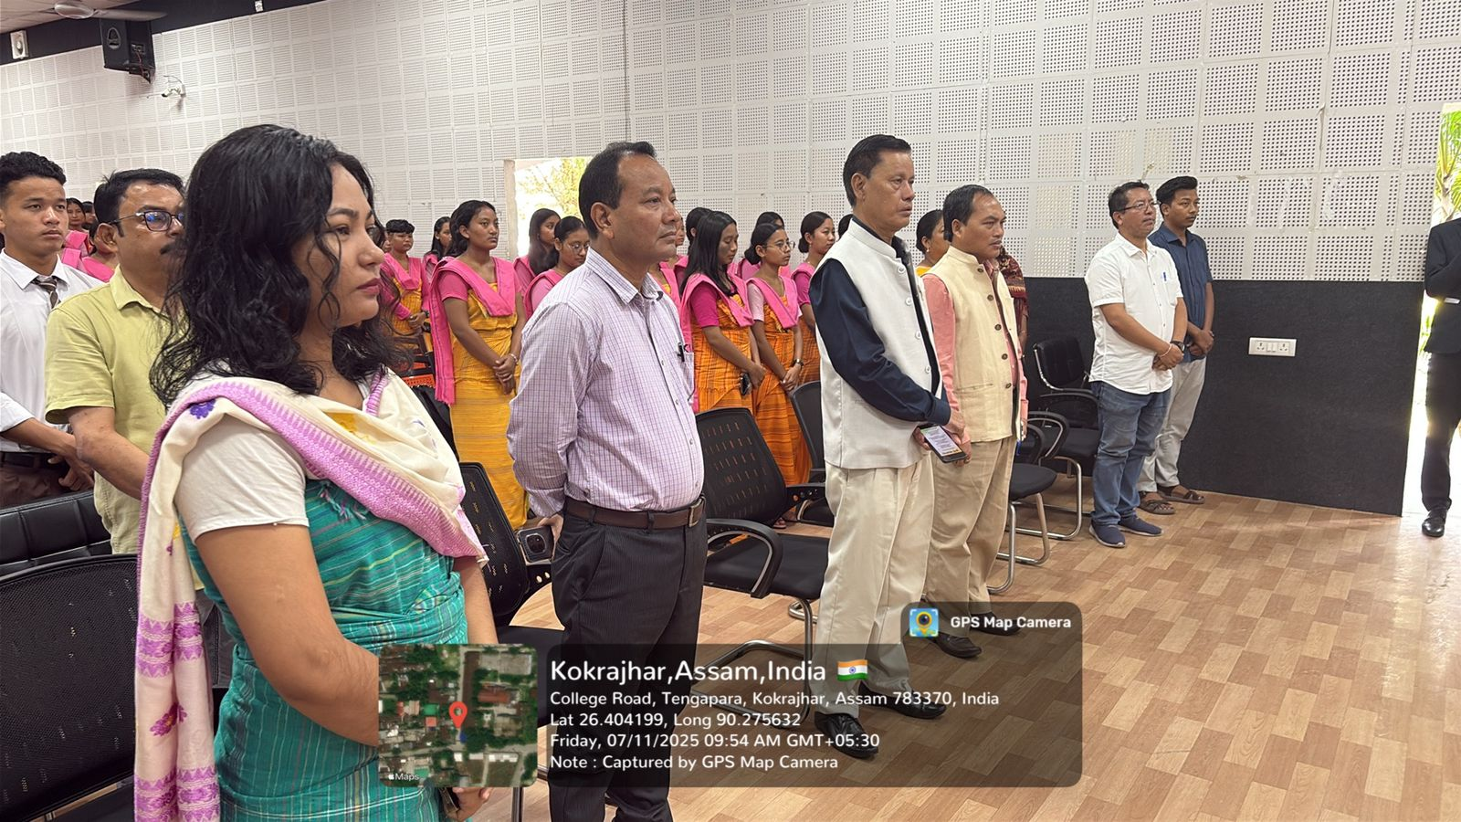
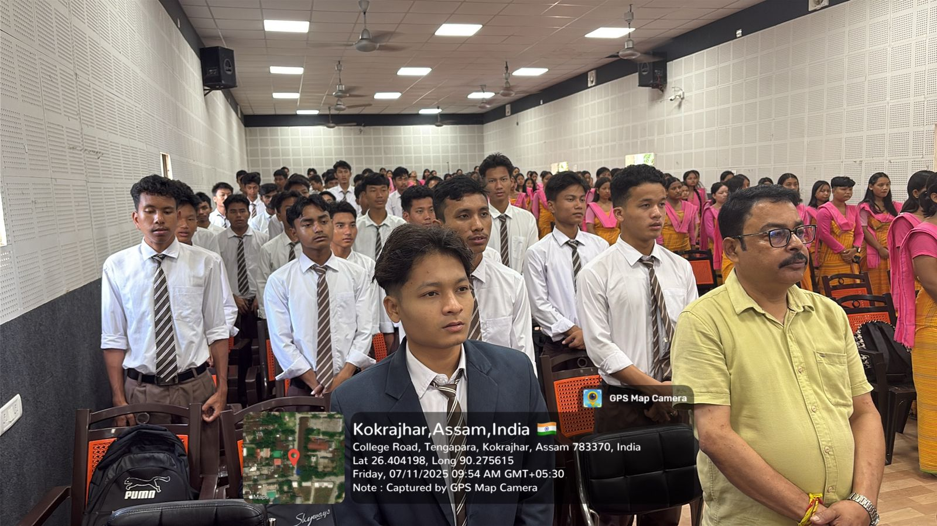
Attendance of the Programme
