Report on Awareness Program
on
“Safe Dog Handling and First-Aid for Dog Bites”
Organised by: IQAC, Kokrajhar University
Date: 27th November, 2025
Venue: Seminar Hall, Kokrajhar University
Total Number of Participants: 97 (Session 1) & 80 (Session 2)
The Internal Quality Assurance Cell (IQAC), Kokrajhar University, organised an Awareness Program on “Safe Dog Handling and First-Aid for Dog Bites” on 27th November, 2025, at the University Seminar Hall. The programme was aimed at sensitising students, staff, and community participants on scientific dog-handling techniques and immediate first-aid measures crucial for preventing complications arising from dog bites.
SESSION 1 (10.00 A.M. – 12.30 P.M.)
The first session began at 10.00 a.m. with a warm welcome note and felicitation of the Resource Person, delivered by the Director, IQAC, Kokrajhar University.
This was followed by an Inaugural Speech by the Hon’ble Vice Chancellor, who highlighted the importance of public awareness and responsible handling of animals in ensuring community safety.
The session continued with a detailed Presentation by the Resource Person, Dr. Gaurab Kafle, Veterinary Officer, Kokrajhar (Assam) from 10.46 a.m. to 12.00 p.m., covering topics such as understanding of dog’s behaviour, safe approaches to handling, preventive measures, and step-by-step first-aid protocols for bite incidents.
An interactive question-and-answer session was held from 12.01 p.m. to 12.20 p.m., where participants shared concerns and sought clarifications on real-life situations related to stray dog encounters.
The session concluded with a Vote of Thanks delivered by Dr. Bichitra Narzary, Assistant Director, IQAC, at 12.21 p.m., expressing gratitude to the dignitaries, resource person, and participants.
SESSION 2 (1.30 P.M. – 4.00 P.M.)
The second session commenced at 1.30 p.m. with a welcoming note and guest introduction by Dr. Leeladhar Chouhan, Assistant Director, IQAC.
The Dean of Students’ Welfare (DSW) delivered the Inaugural Speech from 1.45 p.m. to 2.10 p.m., focusing on the relevance of such awareness programmes in enhancing student safety and promoting human interactions with animals.
This was followed by an extensive Presentation by the Resource Person from 2.11 p.m. to 3.40 p.m., which covered advanced aspects of understanding dog’s behaviour. safe dog handling, emergency response techniques, preventive measures, and step-by-step first-aid protocols for bite incidents.
Participants engaged actively in the interaction session held from 3.41 p.m. to 3.55 p.m., reflecting the effectiveness and relevance of the discussions.
The programme concluded with a Vote of Thanks by Dr. Bichitra Narzary, Assistant Director, IQAC, acknowledging the contributions of all involved and highlighting the importance of continued awareness initiatives.
Conclusion
The awareness program successfully met its objectives by equipping participants with essential knowledge and practical skills related to dog behaviour, safe handling methods, and first-aid for dog bites. The enthusiastic participation across both sessions reflected the growing need for such educational initiatives within the university and the wider community.



Director, IQAC
Kokrajhar University
Kokrajhar
Assam, 783370

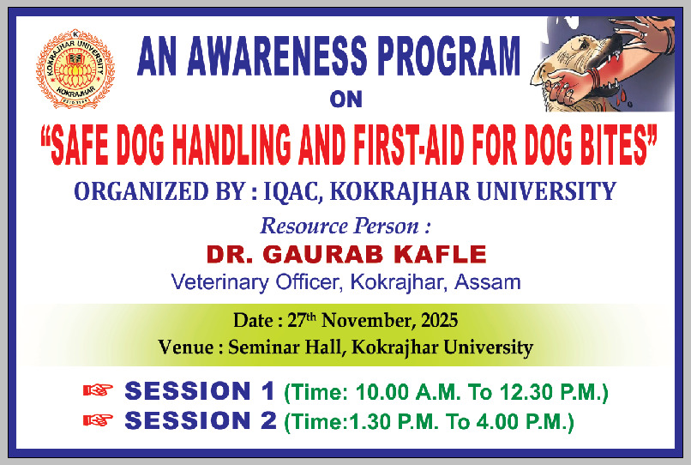
Fig.1: Banner for the Awareness Program on “Safe Dog Handling and First-Aid for Dog Bites” organised by IQAC, Kokrajhar University, Kokrajhar.

Session 1: Participants Attendance Record
Venue: Seminar Hall, Kokrajhar University, Time: 1:30 pm to 4:00 pm
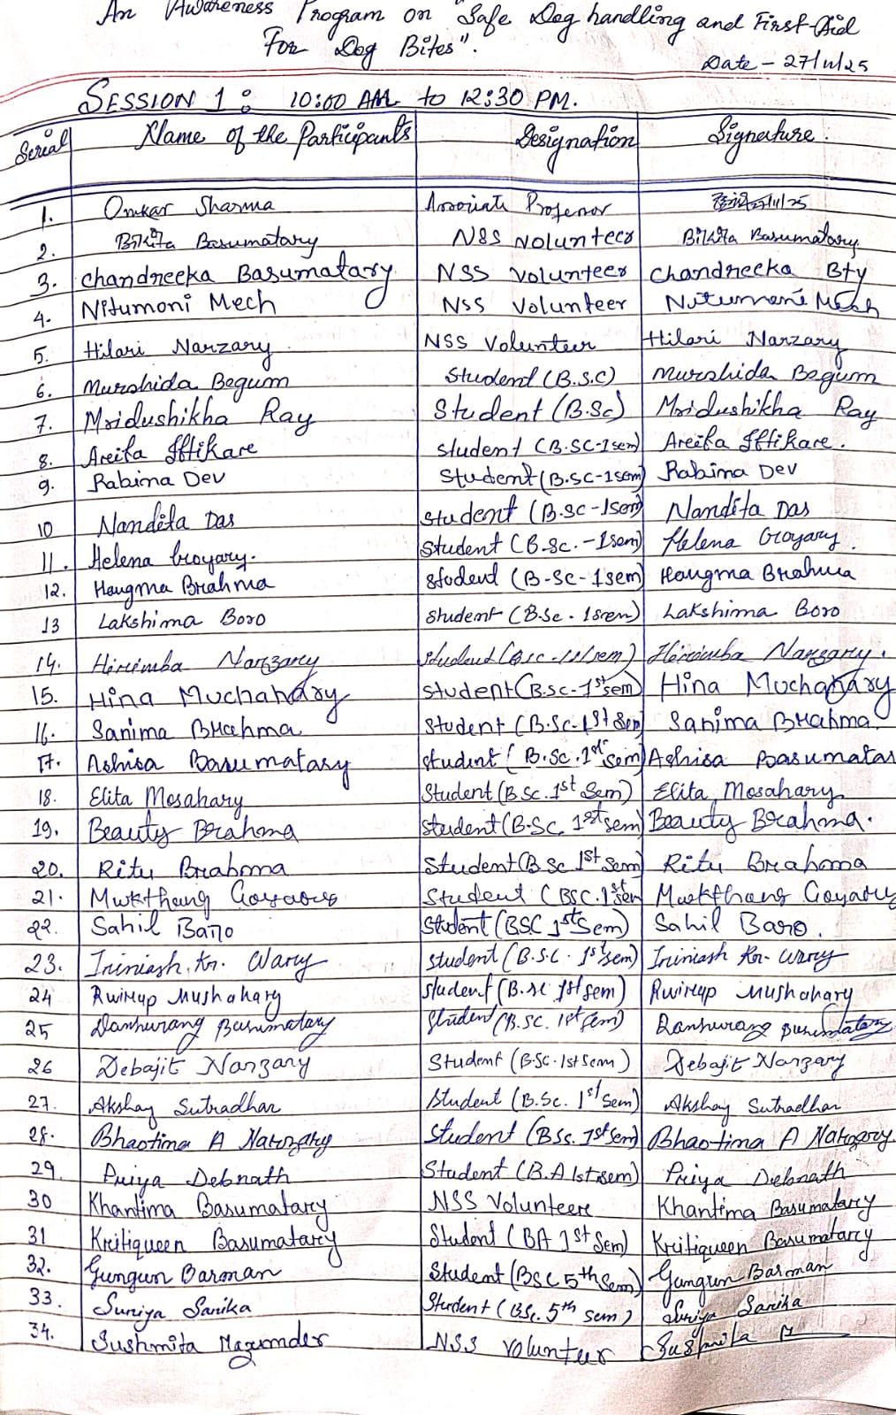
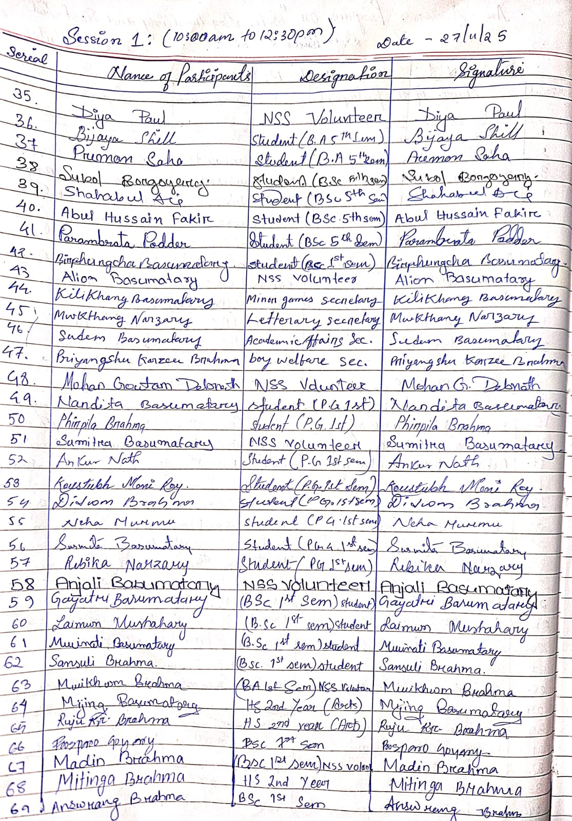
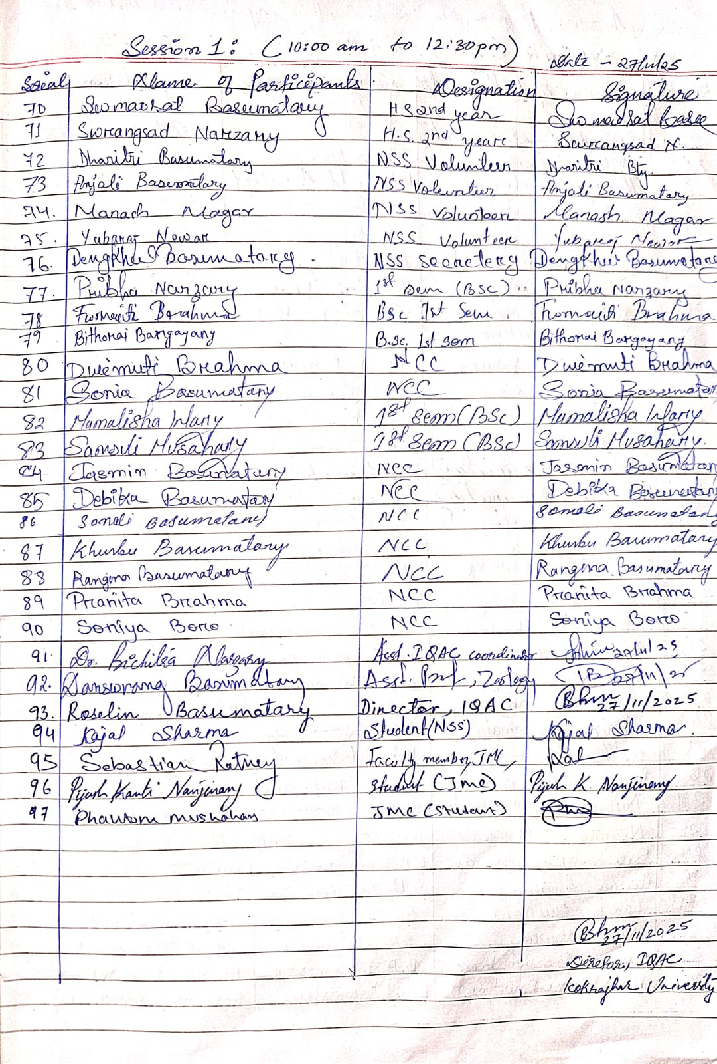
Session 2: Participants Attendance Record
Venue: Seminar Hall, Kokrajhar University, Time: 1:30 pm to 4:00 pm
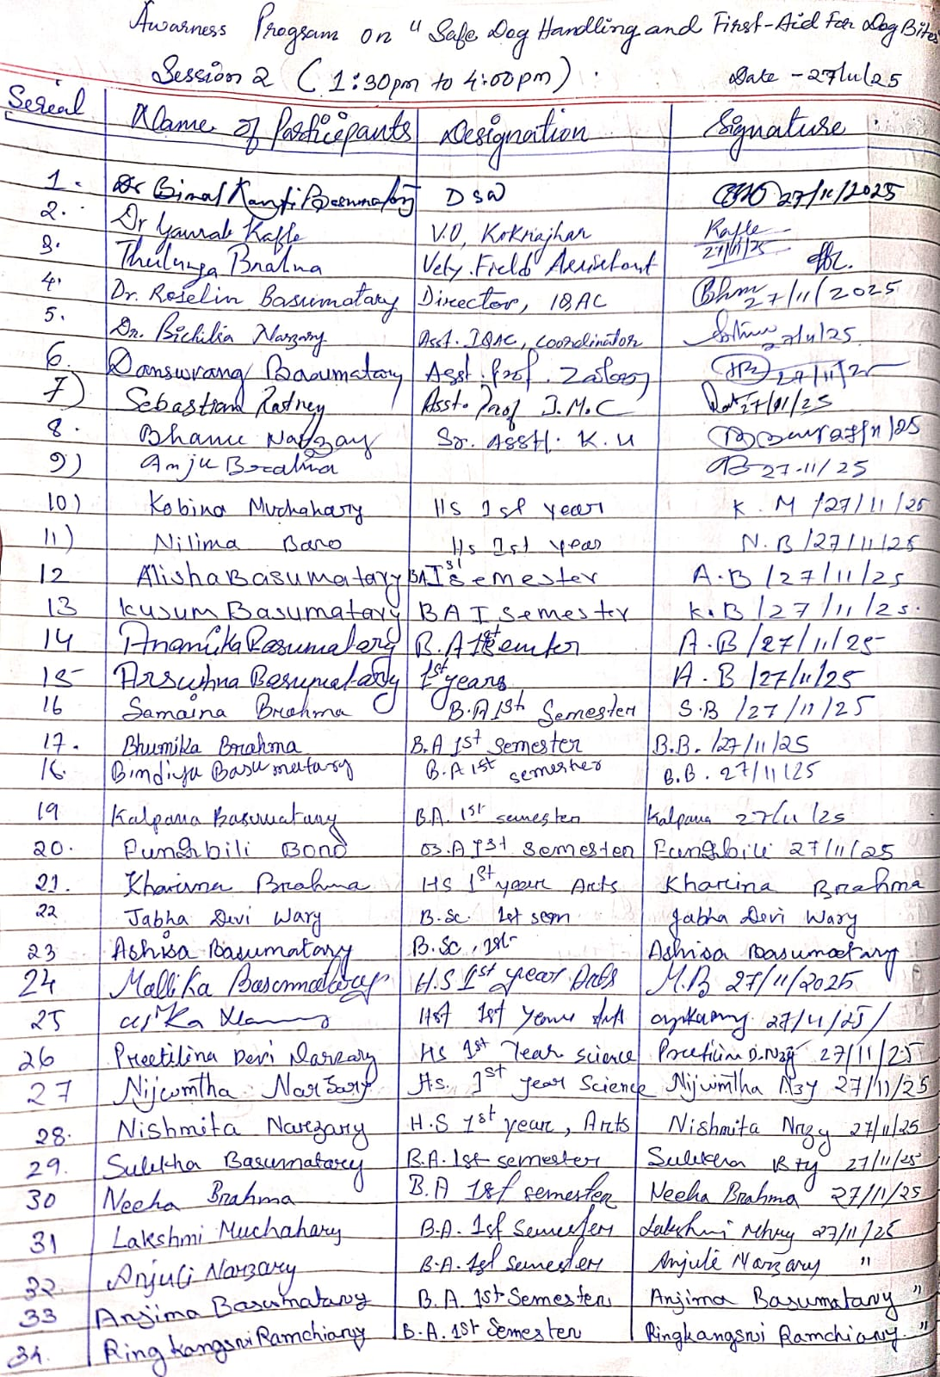

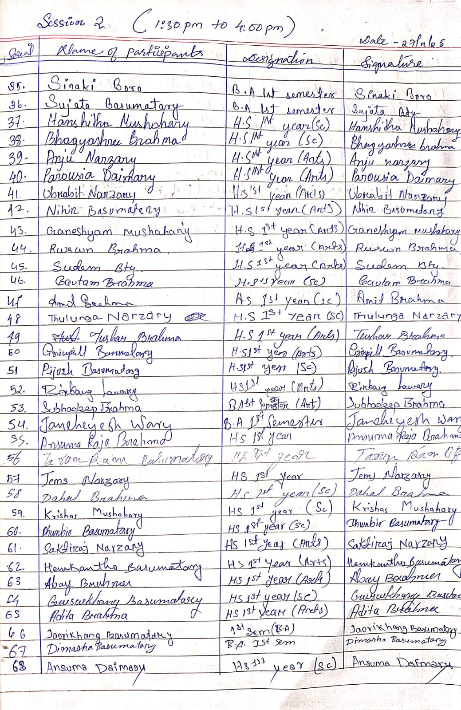

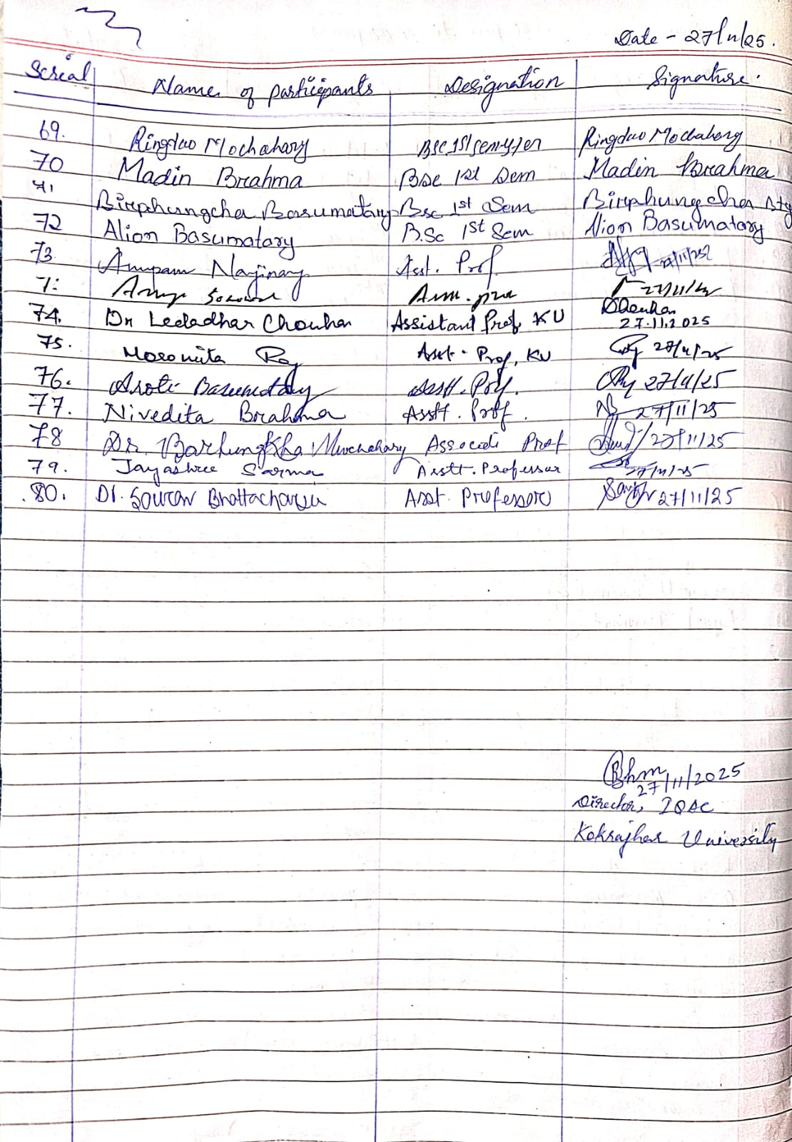
Photo Records of Session 1
Venue: Seminar Hall, Kokrajhar University, Time: 1:30 pm to 4:00 pm
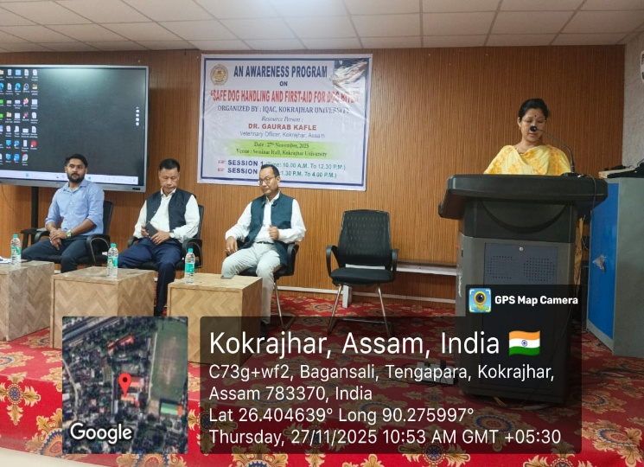  Welcome note by Director, IQAC, KU | 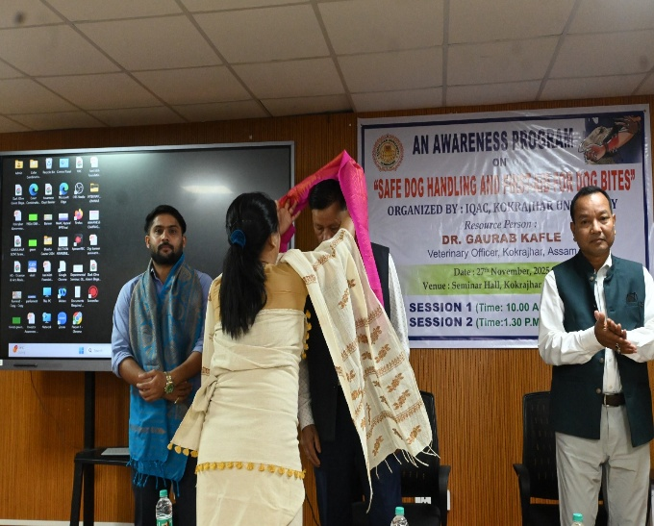  Felicitation of Resource person and Vice Chancellor, KU.
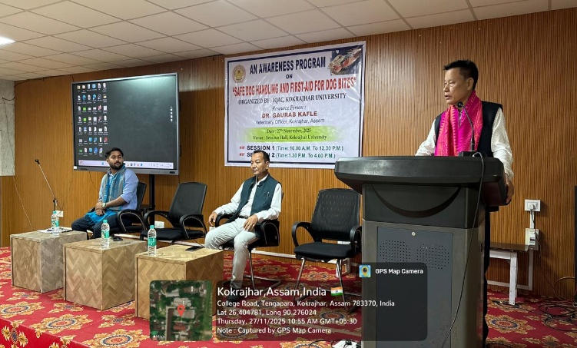  Inaugural Speech by the Hon’ble Vice Chancellor | 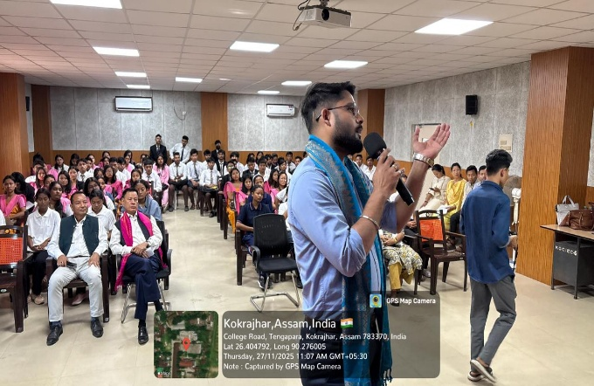  Presentation by the Resource Person
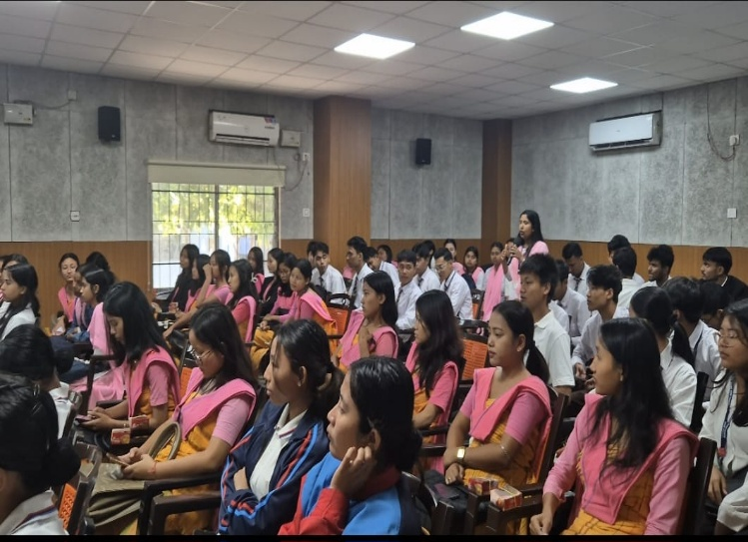  Students Interaction Session with Resource Person | 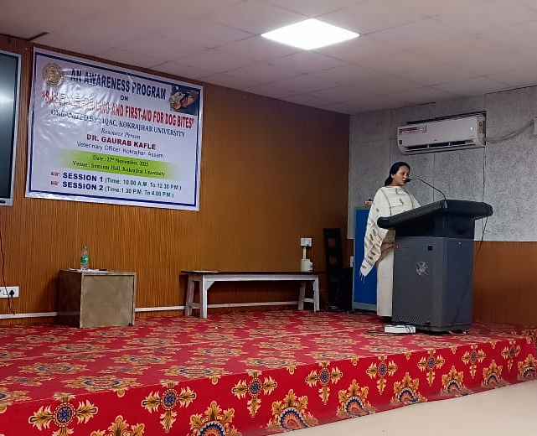  Vote of Thanks by Assistant Coordinator, IQAC, KU
Photo Records of Session 2
Venue: Seminar Hall, Kokrajhar University, Time: 1:30 pm to 4:00 pm
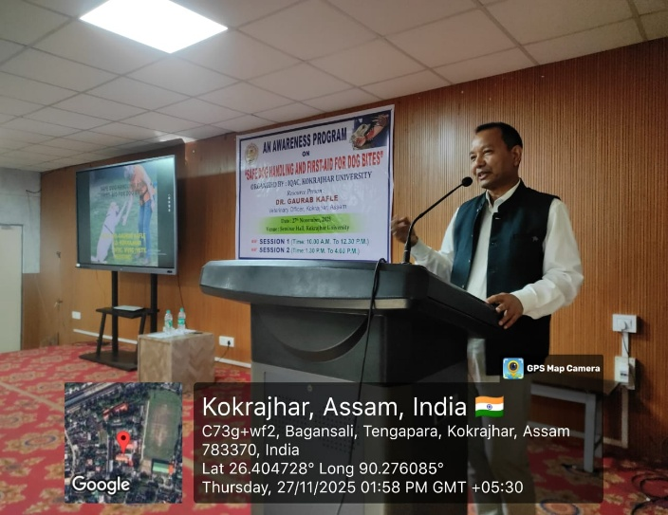  Inaugural Speech by the Hon’ble Dean of Students’ Welfare | 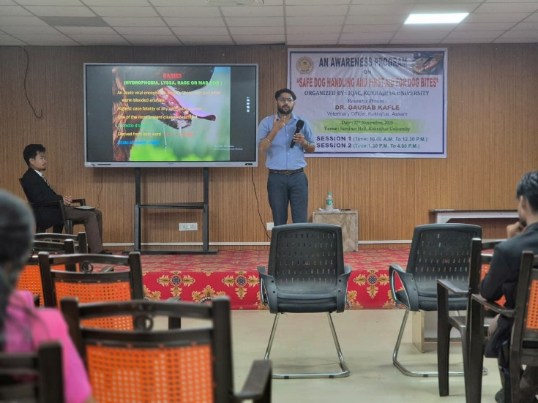  Presentation by Resource Person
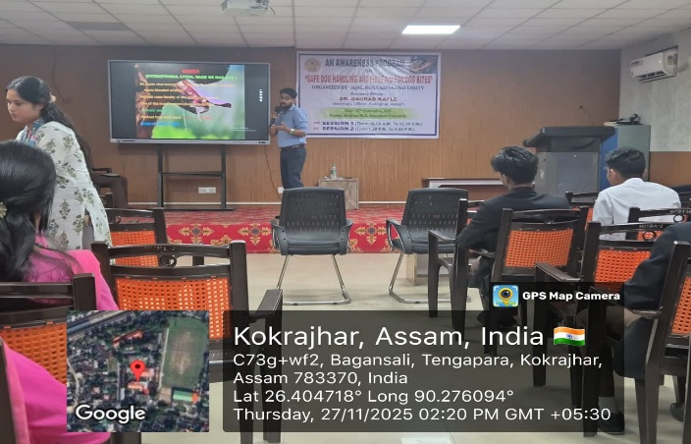  Presentation by Resource Person | 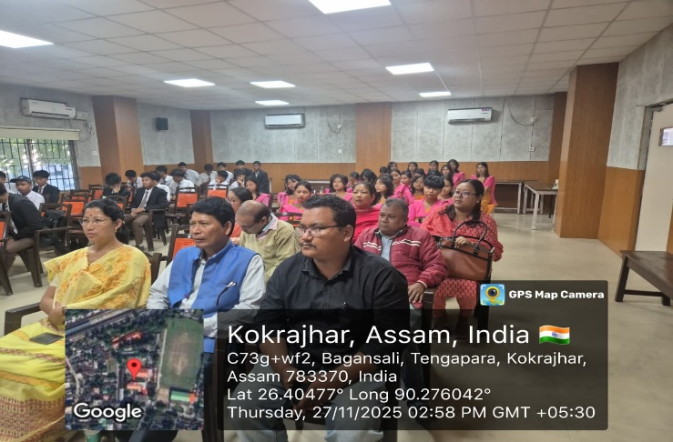  Participants of an Awareness program
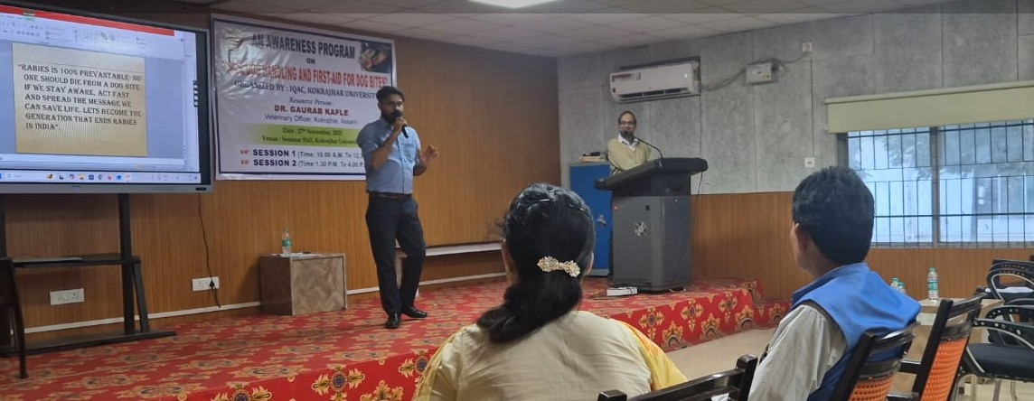  Interaction session during the program | 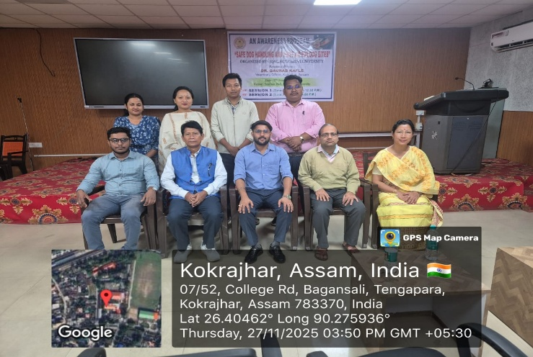  Organizing Team Members with Resource Person

